Advanced Wall 3D

By RimV
http://www.mymedia-art.com
trieuduchien@gmail.com

3D Gallery powered by PV3D is very fashionable nowadays. I indeed love the gorgeous design of wall style and develop that concept further to multil category!

Compatible: Flash 9 + Actionscript 3

Key Features:

- Papervision GreatWhite 2.0 + AS3 .
- Tweener driven
- XML driven.
- Multi Category
- Well commented code.

Installation

This is a requirement to install class paths to PV3D and Tweener for every file. If you have purchased some of my file and installed the class path, you still would need to make a new class path since Advance Wall 3D is built with PV3D GreateWhite 2.0

- In the package, open CLASS folder and copy MyLibs3b to a proper place in your hdd (I placed in Adobe Flash CS3 folder).

- Open Flash – Edit – Preference – Actionscript – Actionscript3 Setting – Add a new class path and browse to MyLibs3b.

- If you have installed MyLibs3 (in case you have purchased one of my file before) you can simply change the path name to MyLibs3b or remove the old path and add a new one

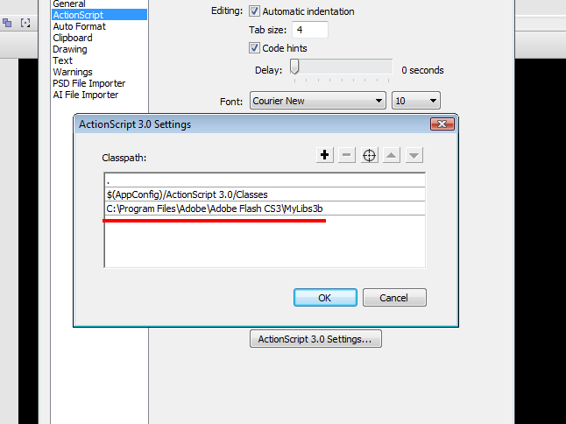

Once a class path is set up, you can compile the movie.

Parameters:

Below is a list of parameters you can customize directly from actionscript:

- easeFactor: easing argurment of Camera's orientation

- cameraTweenTime: tweening duration of moving camera

- cameraTweenEasing: tweening easing type of moving camera

- planeTweenTime: tweening duration of moving plane

- planeTweenEasing: tweening easing type of moving plane

- scrubberTweenTime: tweening duration of moving scrubber in
- Scrollbar

- categoryDistance: Distance between each category plane

- categoryAngle: Angle to rotate when a category plane is clicked

- XDist: Horizontal distance between photo

- YDist: Vertical distance between photo

- moveForward: a quantity to move a photo forward if pressed

- cameraZMin: minimum Z position of camera

- cameraZDefault: default Z position of camera (PNG for example)

- reflection: true if using reflection

- refDist: distance between a plane and its reflection

- refIn1: Reflection Intensity 1

- refIn2: Reflection Intensity 2

- refDen1: Reflection Density 1

- refDen2: Reflection Density 2

- refSmooth: true if using smooth reflection (this param should be
- always false unless you want to have very high quality reflection)

- refDoubleSide: 2 side Reflection

- planeDoubleSide: plane with 2 sides

- planeSmooth: plane applied smoothing

- planePrecise: plane applied precise

- quality: quality of plane

- photoTransparent: true if you want to use photo with transparent area

- transparent: true if you want to use image category with transparent area

- mainXML: a path to main XML file

- css_path: a path to main CSS file

XML:

There is one main XML (adWall3D.xml) which control category, the structure, for example:

<category title="Animals">

<xmlPath src="animals.xml"/>

<image src="asset/animals/categoryImage.jpg"/>

<description><![CDATA[Lorem ipsum dolor sit amet, consectetuer adipiscing elit. Praesent euismod nunc id ligula. Vivamus ac justo. Morbi imperdiet. Lorem ipsum dolor sit amet, consectetuer adipiscing elit. Pellentesque est eros, viverra quis, pellentesque nec, elementum id, mi.]]> </description>

</category>

Each category tag specify a different set of photo, whether:

- Title: the title of category
- xmlPath: the corresponding XML of this category
- image: the image of category
- description: some description

As you may guess, there are XML files for each category as well:

<animals rows="1" columns="15">
<items>
<item>
<image src="asset/animals/sample1.jpg" />
<description> <![CDATA[<title>Photo Description: Animal 1 </title>Lorem ipsum dolor sit amet, consectetuer adipiscing elit. Praesent euismod nunc id ligula. Vivamus ac justo. Morbi imperdiet. Lorem ipsum dolor sit amet, consectetuer adipiscing elit. Pellentesque est eros, viverra quis, pellentesque nec, elementum id, mi ...<a href="event:http://www.flashden.net/user/RimV"> Link </a>]]> </description>
</item>
.
.
.
<items>
<animals>

- Rows and Columns: This specify the form of wall 3D, how many rows and columns you wish to implement, rows * columns should equal to total photos
- Image: the image/photo asset
- Description: description of this photo. You can change link after the word “event” and replace “Link” to your own text

Besides you can customize nearly everthing based on the script included (highly commented).

That’s all folk ☺ Any inquiry sent to my email address: trieuduchien@gmail.com. Due to a large amount of support request it may take a few or many days to reply back. Thanks for your patience

